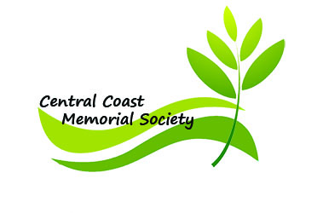

Membership Application

Please complete this application and mail it together with your check.
Donations fund a significant part of our non-profit 501(c)(4), and are appreciated.

In response to your application we will mail you our Mortuary Instruction form. If you have questions, please email or phone us at the numbers below.

Date _____________
Individual Applicant Name ___________________________________________________ (Last) (First) (Middle)
Individual Applicant Name ___________________________________________________ (Last) (First) (Middle)
Address___________________________________________________________________
City, State, Zip _____________________________________________________________
Phone (home)___________________________ (cell) ___________________________
Email _________________________________________
How did you learn about Central Coast Memorial Society? ___ word-of-mouth
___ brochure ___ internet ___ phone book ___ other: _________________________
(Please specify)

Lifetime Membership: $50 per individual adult $________
Optional contribution $ ________
Total submitted $________

